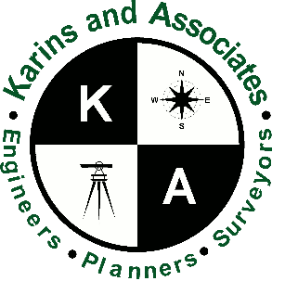
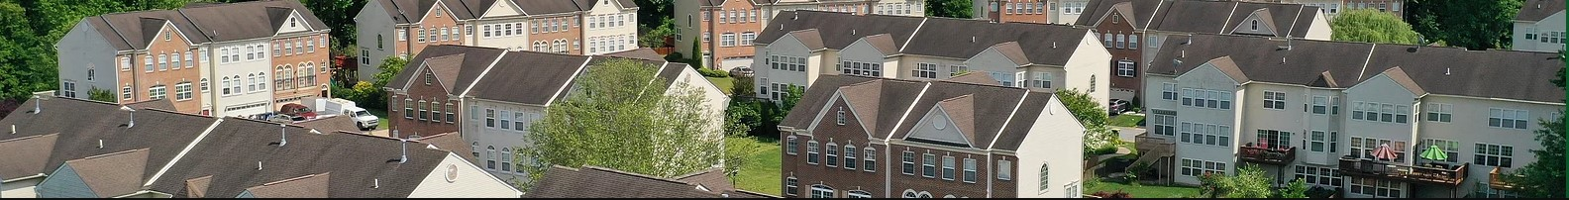
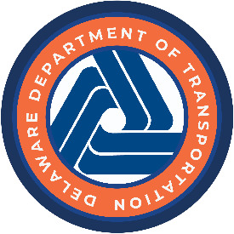
DBE in the Spotlight
Karins and Associates
Karins and Associates is an engineering consulting firm that provides civil engineering and surveying services to Delaware and the surrounding region. With a full staff of professional engineers, land surveyors, and survey crews, the firm offers services including site engineering, high-density laser scanning, storm water management/water resources, utility planning, and construction permitting.
Founded in 1973, the firm is willing to provide site-specific engineering and analyses for complex projects, as well as assist clients with navigating the maze of regulations, design hurdles, and challenging site issues. The firm's experienced field personnel are equipped with the latest technology including robotic total stations, GPS equipment, digital 3D laser scanning equipment, and a robotic unmanned surface vessel (USV) for hydrographic surveying.
The firm creates masterpieces for an assortment of clients ranging from private firms, municipalities, and governmental agencies in Delaware, Pennsylvania, and Maryland. Karins and Associates has contributed to different projects in residential, commercial, and institutional areas such as the Silver Maple Farm 55+ community housing development in Middletown, DE and the Rockford Tower in Rockford Park in Wilmington, DE.
Karins and Associates has become a trusted adviser to public and private clients by providing practical approaches to their individual project needs. The firm is committed to creating extraordinary projects that come alive in the communities they serve and aims to work with the upcoming generation of engineers to bring more talent to the company and expand their project offerings.
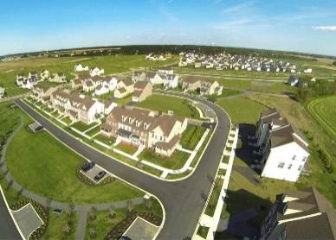
Contact Us:
Email us: info@karinsengineering.com
or Phone: (302) 369-2900

